NUSP - Namal University Societies Platform
Project Proposal
CSC-225 - Software Engineering
Complex Computing Problem - Milestone 1
By
# | Name | Roll No
1 | Muhammad Abubakar | NUM-BSCS-2025-28
2 | Sobia | NUM-BSCS-2025-54
3 | Muhammad Zaviar Hashmi | NUM-BSCS-2025-43
4 | Sania Fatima | NUM-BSCS-2025-51

Department of Computer Science
Namal University, Mianwali
Submission Date: 7th October, 2026
GitHub Repository: https://github.com/Abubakr2916/NUSP

REVISION HISTORY
Date | Version | Description | Approved by
05-10-2026 | V 1.0 | Initial Submission of the project in which all the features were finalized and we were told to remove event registrations of students and make one section of upcoming events. It was also discussed that initially only ‘chief in patrons’ will be designed and later all the patrons will have their own dashboards | Mam Asiya Batool

TABLE OF CONTENTS
 | INTRODUCTION | 4
 | PROBLEM STATEMENT | 4
 | PROJECT OBJEC TIVES | 4
 | PROJECT SCOPE | 5
 | STAKEHOLDER IDENTIFICATION | 6
 | SOFTWARE DEVELOPMENT METHODLOGY | 6
 | TOOLS AND TECHNOLOGIES | 8
 | REFERENCES | 9
 | AI PROMPT USED | 9

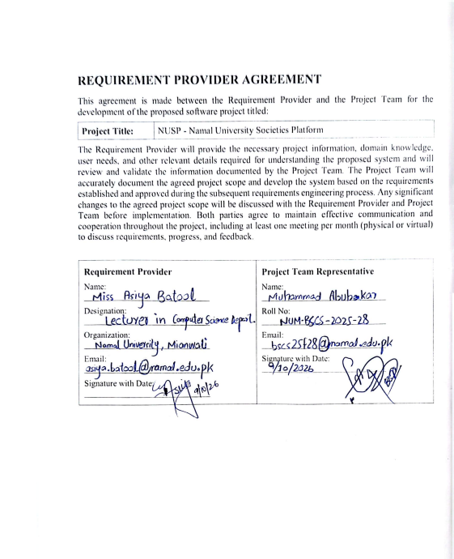

INTRODUCTION
Student societies are part of university life because they help students develop leadership, teamwork and personal skills while taking part in activities outside studies. At Namal University, different societies organize events, seminars, workshops, competitions and social activities throughout academic year. However, information about societies, their leaders, announcements, memberships and activities is shared through different channels, which makes it difficult for students and visitors to find everything in one place
NUSP (Namal University Societies Platform) is a website based platform proposed to bring all university societies together in one place. It will allow visitors to explore societies, check upcoming events, view photos and videos of past events, and learn about society leadership. Verified Namal students will also be able to use their university email accounts to apply for society memberships and positions in society bodies.
The project focuses on campus services and aims to make society information easier to access, improve communication, and help manage student societies at Namal University.

PROBLEM STATEMENT
Society related information at Namal University is currently provided across different platforms, which makes it difficult for students and visitors to stay updated about the society activities. There is no centralized platform where all societies can manage their information, leadership, announcements, memberships and upcoming events.
Students also face difficulties in applying for society bodies, while society management lacks a structured mechanism for handling applications and maintaining records. Furthermore, there is no system to ensure that only eligible Namal students can apply for society positions. This effects students, society patrons, the chief in patrons and also it makes hard for external visitors too.
NUSP aims to solve these problems by making a website that supports public access, student authentication, society management, and administrative control.

PROJECT OBJECTIVES
The project aims to achieve the following objectives:
- To develop a centralized platform that manages all Namal University societies in one place.
- To provide public access to society information, leadership details, galleries, and upcoming events without requiring login.
- To implement a university email based authentication system so that only verified Namal students can submit membership applications.
- To automate the application process for General Body, Executive Body, and Core Body positions, including eligibility checks and the one society per student rule.
- To provide separate dashboards for the administrators of societies for efficient management and monitoring of societies.

PROJECT SCOPE
This section defines the boundaries of NUSP: what the system will cover in its initial version, the rules it will enforce, and what is intentionally left out.

Public Features
- Landing page
- Chief Patron video message
- Society information pages
- Upcoming events section
- Event galleries (photos and videos from previous years)
- Society leadership details
- Announcements

Student Features
- Login using university email
- Apply for society memberships for General Body, Executive Body, and Core Body
- Application tracking
- Restriction to join only one society at a time

Society Patron Dashboard
- Manage society information
- Open and close applications
- Review student applications
- Upload gallery images
- Publish announcements

Chief Patron Dashboard
- View all societies
- Manage society activities
- Monitor memberships
- Publish university-wide announcements

System Modules
The system will be organized into the following modules:
    - Public Module: home page, society pages, upcoming events, gallery, and announcements.
    - Student Module: login, profile, and membership applications.
    - Society Management Module: applications, announcements, and society information.
    - Administration Module: Chief Patron dashboard and Society Patron dashboard.

User Roles
NUSP defines four user roles i.e. public visitor, student, society patron, and chief patron. Public visitors can browse all public content, students can additionally log in and apply for memberships, Society Patrons manage their own society, and the Chief Patron oversees all societies.

STAKEHOLDER IDENTIFICATION
The following people and groups interact with, or are affected by, the proposed system.
Stakeholder | Role | Interaction with System
Public Visitors | Explore societies | View society pages, upcoming events, galleries, leadership details, and announcements
Students | Society applicants | Log in with university email and apply for General, Executive, or Core Body; track applications
Society Patrons | Society management | Manage society information, open/close and review applications, upload gallery media, publish announcements
Chief Patron | University-level management | Monitor all societies and memberships, manage society activities, publish university-wide announcements
Society Members | Participate in activities | View society information, announcements, and events
University Administration | Future adopters | Monitor the overall system and its use
Table # 1: Stakeholders and Their Roles in the Proposed System

SOFTWARE DEVELOPMENT METHODOLOGY

Selected Methodology
The Scrum framework of Agile software development will be used for this project. Scrum is suitable because requirements may change after discussions with the Requirement Provider and society patrons. It allows the team to develop the system in smaller modules, obtain regular feedback, identify issues early, and improve features incrementally through short development cycles called sprints.

How the Methodology Guides Development

The project will be organized into short iterations called Sprints, with each sprint delivering a working increment of the system. Initial activities will include requirement gathering, analysis, and design, followed by implementation, testing, and integration. The team will track tasks and progress using GitHub Issues and GitHub Projects. At the end of each sprint, the team will review completed features, identify problems, and plan improvements for next sprints. Feedback will be collected from the Requirement Provider through monthly meetings, documented in meeting minutes, and used to update and prioritize the product backlog. Any agreed changes to the project scope will be discussed with the Requirement Provider before implementation. A tentative one-year Gantt chart will be used to plan and monitor the major project activities, including deployment and final documentation.

Tentative Schedule
A development schedule of one year is assumed. Table lists the major phases and Figure shows the tentative Gantt chart.
Table 2: Tentative One-Year Project Plan
Phase | Duration | Main Activities
Requirement Gathering | Month 1 | Meet the RP, finalize the proposal and scope
Analysis & Design | Month 2 | Requirement analysis, use cases, system and database design
UI/UX Design | Month 3 | Wireframes and prototypes in Figma
Frontend Development | Months 4–5 | Public, student, and dashboard interfaces in React
Backend Development | Months 6–7 | APIs, authentication, and business rules in Node.js/Express
Database Development | Month 8 | MySQL implementation and data access
Integration | Month 9 | Connect frontend, backend, and database
Testing | Months 10–11 | Functional, integration, and user acceptance testing
Deployment & Documentation | Month 12 | Deployment, final documentation, and handover

Activity / Month | 1 | 2 | 3 | 4 | 5 | 6 | 7 | 8 | 9 | 10 | 11 | 12
Requirement Gathering
Analysis & Design
UI/UX Design
Frontend Development
Backend Development
Database Development
Integration
Testing
Deployment & Documentation
Monthly RP Meetings
Figure # 1: Tentative Gantt Chart

TOOLS AND TECHNOLOGIES
The following tools, languages, frameworks, and platforms will be used to develop NUSP.
Table # 3: Proposed Tools and Technologies
 | Tools and Technology | Purpose
1 | HTML | Page structure
2 | CSS | Styling
3 | JavaScript | Interactivity
4 | React.js | Frontend development
5 | Node.js | Backend runtime
6 | Express.js | Backend framework
7 | MySQL | Database management
8 | Git | Version control
9 | GitHub | Repository management
10 | Figma | UI/UX design
11 | Visual S tudio Code | Development environment

Reason Of Selection Of Each Tool

MySQL is selected because it is easy to learn, widely used, and well suited to relational data. NUSP needs to store related records such as students, societies, memberships, applications, events, and galleries. React.js is used for the frontend because its component-based approach suits reusable pages such as society profiles and dashboards. Node.js with Express.js lets the team use JavaScript on both the frontend and the backend. Figma supports collaborative UI/UX prototyping before development begins, and Git with GitHub provides version control and shared repository management for the whole team.

REFERENCES
[1] K. Beck et al., “Manifesto for Agile Software Development,” 2001. [Online]. Available: https://agilemanifesto.org
[2] Meta Platforms, Inc., “React: The library for web and native user interfaces.” [Online]. Available: https://react.dev
[3] OpenJS Foundation, “Node.js.” [Online]. Available: https://nodejs.org
[4] OpenJS Foundation, “Express.” [Online]. Available: https://expressjs.com
[5] Oracle Corporation, “MySQL Documentation.” [Online]. Available: https://dev.mysql.com/doc/
[6] Figma, “Figma.” [Online]. Available: https://www.figma.com
[7] Software Freedom Conservancy, “Git.” [Online]. Available: https://git-scm.com
[8] K. Schwaber and J. Sutherland, “The Scrum Guide,” 2020. [Online]. Available: https://scrumguides.org/scrum-guide.html

AI PROMPTS USED
AI tools were used only for modifying and checking the possibility of implementation of idea and its features. This proposal was reviewed and finalized by the project team. The prompts and queries used are listed below.
 | Prompt / Query
1 | i am doing my software engineering project on creating a website for namal university societies where all societies can be managed and all the events and upcoming events and there registrations and all the other related work is done.
2 | I want to name his project NUSP (Namal University Society Platform. Is it professional?
3 | first of all today I must finalize all the details of what will be in the website so so far we have decided  - A landing page  - on the landing page we need to have a you know under menu there should be a video of chief patron  - under this we should have a section of events which are very near and after that we should have a section of all the upcoming events  - now there is another condition too that students who want to be registered for the events of different societies must go to the pages of the respective society and register themselves  - Now for the chief patron, there should be a separate dashboard on which he can go or something like that and from there he can control all the societies activities  - also on the societies menu I want you do something like if one wants he can see the patron, co-patron, core body, executive body and general body of the society  - also when the registration of the societies respective bodies open then only students can apply  How do I pitch this to my mam so that she is convinced that we can do this project?
4 | generate an image of how the public, students and managements will look in actual website
5 | Appropriate questions one can ask to an IT person for this project and sound more professional so that they actually listen to me like I am serious.
6 | What is single sign-on system?
7 | should I add this gantt chart in the proposal or not if yes what is it and why is it important?
8 | I am thinking of using Scrum methodology for this project because there are monthly meetings etc so is it a right choice for this project?

